Pre-Requisites

Team ID | PNT2022TMID13933
Project Name | Smart Lender- Applicant Credibility Prediction for Loan Approval

Anaconda Navigator

Anaconda is an open-source software that contains Jupyter, Spyder, etc that are used for large data processing, data analytics, heavy scientific computing. It works for R and python programming language.
- Spyder(sub-application of Anaconda) is used for python. Opencv for python will work in Spyder. Package versions are managed by the package management system called conda.

Download and install Anaconda:

1. Click anaconda.com and install the latest version of Anaconda. Make sure to download the “Python 3.7 Version” for the appropriate architecture.
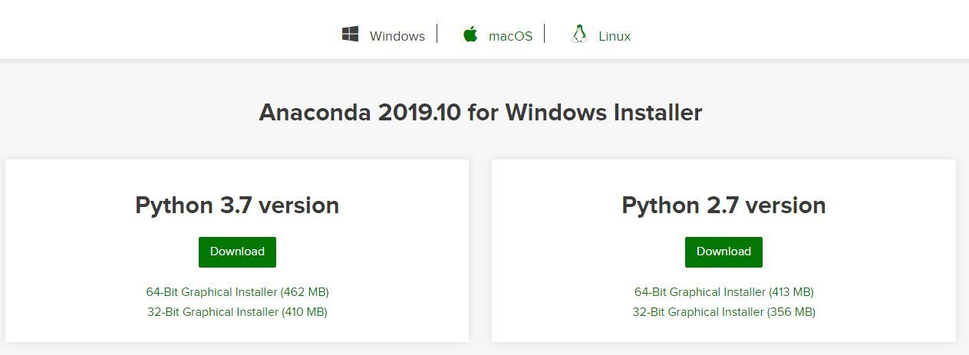

Installation process :
Getting Started:
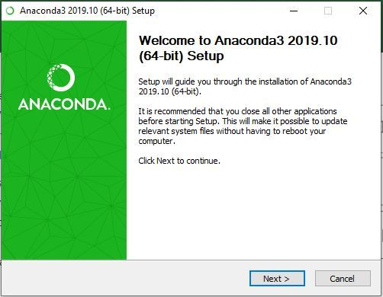

Getting through the License Agreement:

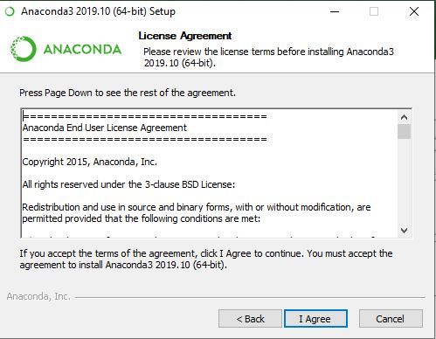

Select Installation Type:Select Just Me if you want the software to be used by a single User
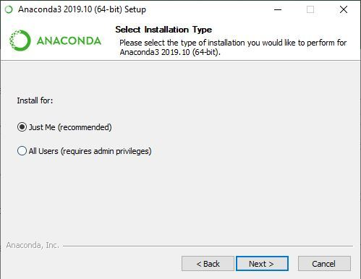

Choose Installation Location:
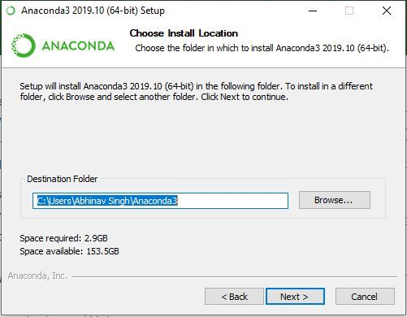

Advanced Installation Option:

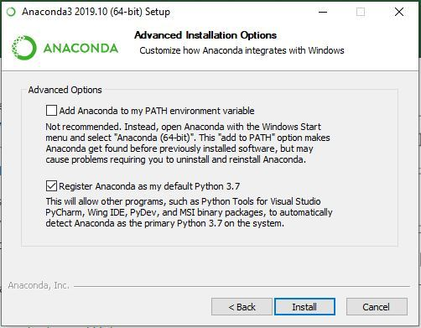

Getting through the Installation Process:
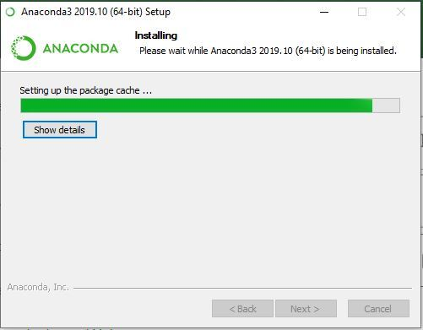

Finishing up the Installation:

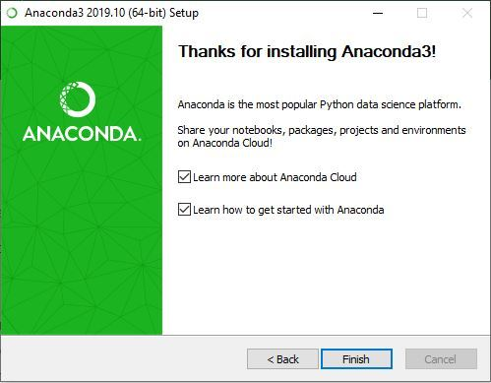

Working with Anaconda:
Once the installation process is done, Anaconda can be used to perform multiple operations.
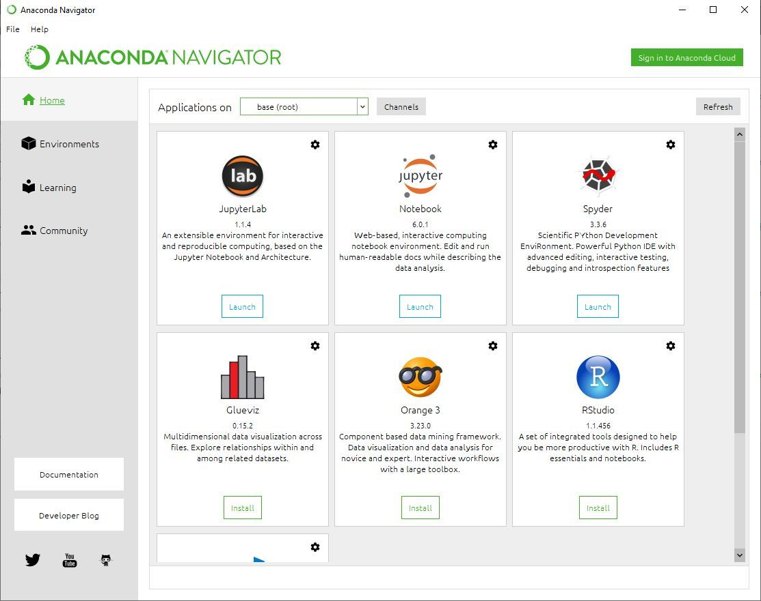

Run Python in a Jupyter Notebook

- On Navigator’s Home tab, in the Applications pane on the right, scroll to the Jupyter Notebook tile and click the Install button to install Jupyter Notebook.
- Launch Jupyter Notebook by clicking Jupyter Notebook’s Launch button.
- On the top of the right hand side, there is a drop-down menu labelled “New”. Create a new Notebook with the Python version you installed.
- Rename your Notebook. Either click on the current name and edit it or find rename under File in the top menu bar. You can name it to whatever you’d like, but for this example we’ll use MyFirstAnacondaNotebook.
- In the first line of the Notebook, type or copy/paste print("Hello Anaconda").
- Save your Notebook by either clicking the save and checkpoint icon or select
File- Save and Checkpoint in the top menu.
- Run your new program by clicking the Run button or selecting Cell- Run All from the top menu.
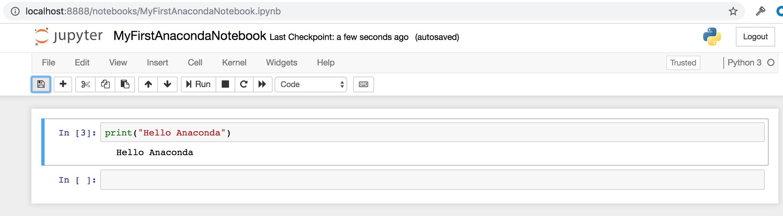

Run Python in Spyder IDE

On Navigator’s Home tab, in the Applications pane on the right, scroll to the Spyder tile and click the Install button to install Spyder.
    - Launch Spyder by clicking Spyder’s Launch button.
    - In the new file on the left, delete any placeholder text, then type or copy/paste print("Hello Anaconda").
    - In the top menu, click File - Save As and name your new program hello.py.
    - Run your new program by clicking the triangle Run button.
    - You can see your program’s output in the bottom right Console pane.
